EXPERIMENT – 07
Create a Virtual Machine with 1 CPU, 2GB RAM and 15GB storage disk using a Type 2 Virtualization Software, using virtual box.
Aim:
To create a Virtual Machine with 1 CPU, 2GB RAM, and 15GB storage disk using a Type-2 Virtualization Software (VirtualBox).
Procedure:
- Install VirtualBox: Download and install Oracle VirtualBox on your host system.
- Launch VirtualBox: Open the VirtualBox Manager and click on New to create a new VM.
- Name & OS Selection:
Enter VM name (e.g., Ubuntu-VM or Windows-VM).
Select Type: Windows/Linux.
Choose version (e.g., Ubuntu 64-bit or Windows 10).
4.Allocate Memory (RAM): Assign 2048 MB (2GB) RAM.
5.CPU Configuration: In Processor settings, allocate 1 CPU core.
6.Create Virtual Hard Disk: Select Create a virtual hard disk now.
7.Choose format as VDI (VirtualBox Disk Image).
8.Allocate 15 GB storage (dynamically allocated or fixed size).
9.Mount OS ISO: Go to VM Settings → Storage → Attach the OS ISO image (Linux/Windows).
10.Start the VM: Boot the VM and proceed with OS installation.

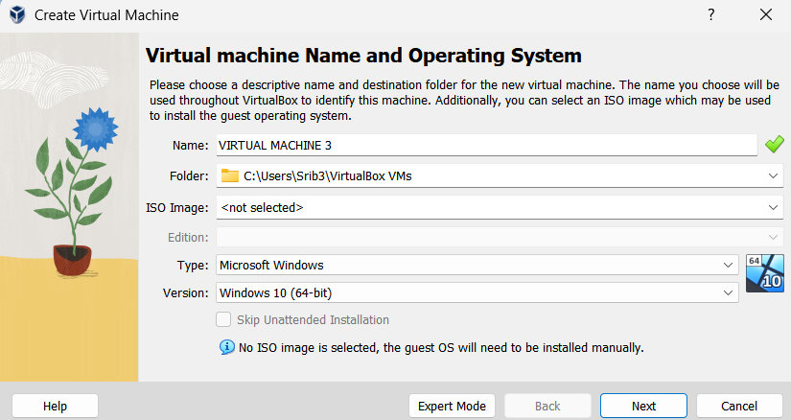
Output: 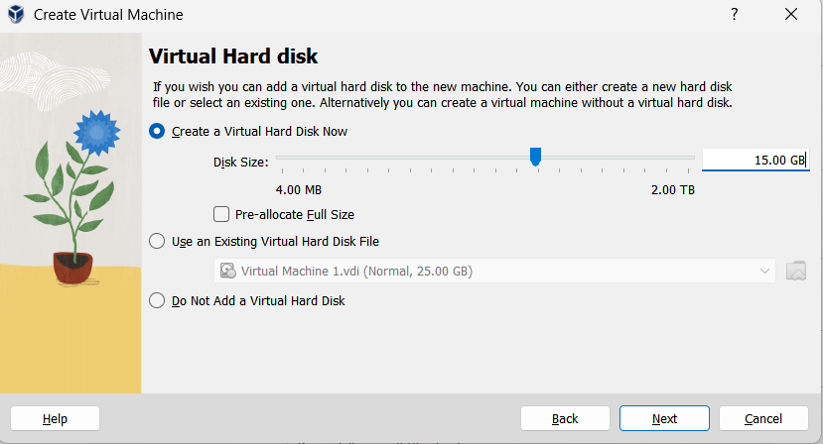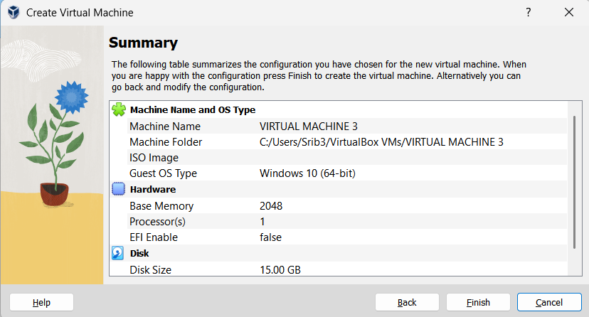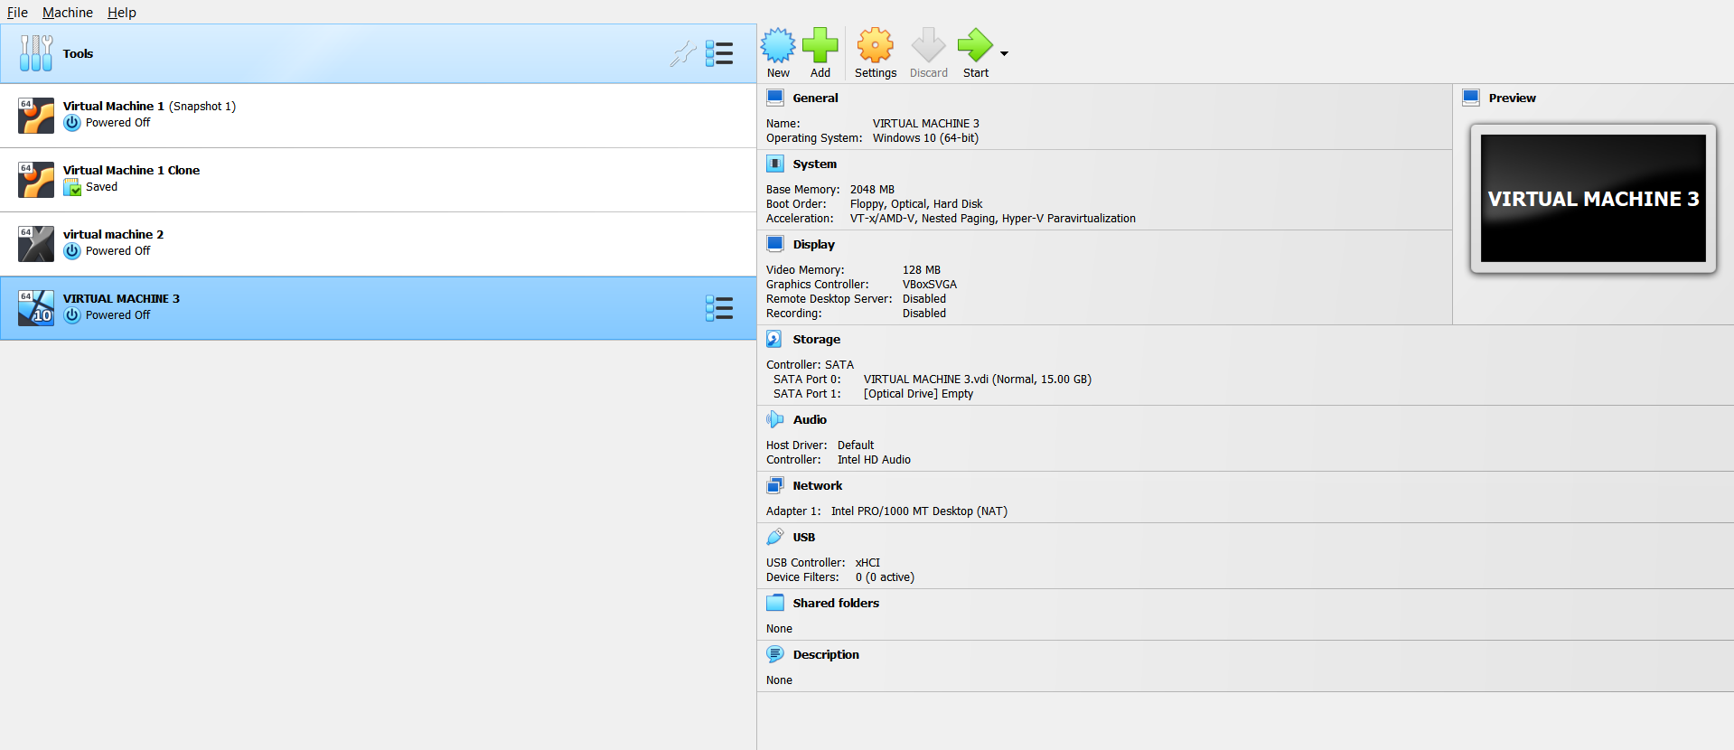Result:
A Virtual Machine with 1 CPU, 2GB RAM, and 15GB storage disk was successfully created and configured using VirtualBox.

